Road 2 Resiliency Coalition Meeting
3:30 – 4:45 PM February 26th, 2018
Pacific County Annex Building

Members Present: Zoe Sowa, Gracie Manlow, Pam Nogueira, Jessica Verboomen, Carly Castaneda, Kat Staats, Tessa Clements, Katie Lindstrom, Peter McNamara
AGENDA ITEM | DISCUSSION |  | DECISIONS, ACTIONS, ASSIGNMENTS
Approval of February’s Minutes | Last meeting’s minutes were reviewed |  | Carly moved to approve, Tessa 2nd/Passed
Coalition Promotion & Branding | - Promotional Mock-Ups were passed around (see attached)  - Promo materials should ideally be matched with events R2R hosts  - TimerCaps for Rx Takeback  - Rubber Band Bracelets for Class Action  - Pop Sockets for Class Action  - Water Bottle Stickers for all events with refreshments provided
Activity Map (DBHR Timeline)  See attached for updated Activity Map | (2018)  May | Elevator Pitch Presentation (Carly)  Starts with One Media Campaign  Teacher Appreciation Day | Call for volunteers: April
 | June | Opioid Response
 | July | CADCA Mid-Year Institute | Youth Officers?
 | Aug | Safe Rx Program  Back to School BBQ | WBH/Mary Ann/  Grilling Burgers?
 | Sept
 | Oct | Rx Takeback  Coalition Assessment Tool (CAT)
 | Nov | WA Prevention Summit
 | Dec
(2019)
Jan
 | Feb | CADCA Leadership Forum
 | Mar | Guiding Good Choices
 | April | Guiding Good Choices  Starts with One Media Campaign
 | To be assigned dates:  - Town Hall  - Kiwanis Scholarship Dinner  - Poverty Simulation  - Class Action |  | Waiting on:  - Next Mtg  - DBHR Check-in  - School Schedule  - Prevention Dates
Member Announcements | - Guns&Hoses is happening March 10th!  - Business Week still needs volunteers for Community Advisors and Judges! |  | - Contact Zoe if you’d like to volunteer  - Contact Kat Staats
Next Meeting | - Our next meeting is April 2nd |  | - See you there!

R2R Promo Fact Sheet
TimerCap (TimerCap.com)
Opioid Kit $2.45/kit, better pricing if we order 5,000 + (Collaboration with TAC & WellSpring?)
Lanyard (4imprint.com)
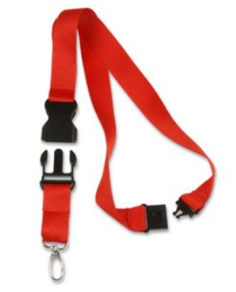One color text print $202.50/150 ($1.35 ea.)
Pens (Vistaprint)
$82.85/100 Pens, $114/200 Pens
Rubber Bracelets (24hourwristbands.com)
$134/500 bands ($0.26/band)
PopSockets (Crestline.com)
$523/100 pop sockets with logo

Mugs (4imprint.com)
72 for $97.20 ($1.35 ea)
Water Bottles (Vistaprint.com)
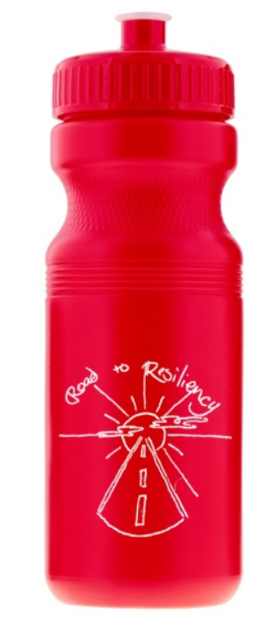Min order of 300 $506.96 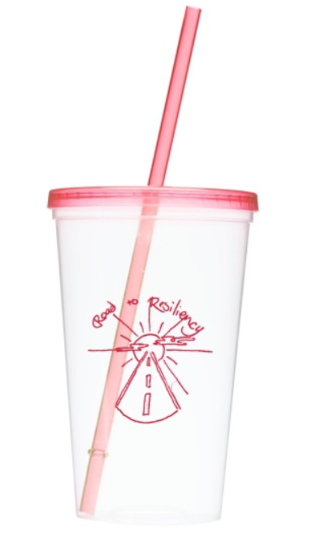Min order of 200 $395.37
Water Bottle Stickers (UPrinting.com)
1000 2.5”x8” Glossy Labels for $112.73
Drawstring Backpack (Vistaprint.com)
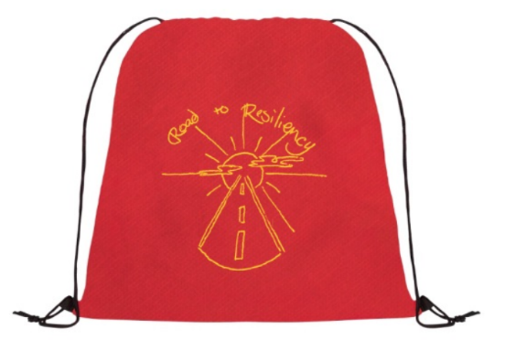Min order of 200 for $312.39
Magnets (Vistaprint.com)
Business Card Size, 100 for $23.99 ($0.24/magnet) 200 for $41.24 ($0.21/magnet)
Coalition Timeline – Year One
2017
August | September | October | November | December
 |  | Rx Takeback | WA Prevention Summit | Town Hall

2018
January | February | March | April
Coalition Assessment Tool | CADCA Leadership Forum | Guiding Good Choices  Class Action  Starts with One Media Campaign | Guiding Good Choices  Class Action  Starts with One Media Campaign  Rx Takeback

Coalition Timeline – Year Two
2018
May | June | July | August
Elevator Pitch (Carly)  Starts with One Media Campaign  Teacher Appreciation | Opioid Response | CADCA Mid-Year Institute | Safe Prescriber  Back to School BBQ
September | October | November | December
 | Rx Takeback  Coalition Assessment Tool | WA Prevention Summit
2019
January | February | March | April
 | CADCA Leadership Forum | Coordinator CPP  Guiding Good Choices | Rx Takeback  Guiding Good Choices  Starts with One Media Campaign

